|  |  |
| --- | --- |
| Course name:  Diploma in Software and Design | |
| Assignment title | **DSD-04 Agile Group Project** |
| Assessment weighting | *Need to pass the assessment to complete the course* |
| Passing Criteria: | Need to score 50% or more to pass the assessment.  **Total Marks: 100** |
| Due date: | **Your Tutor will advise you**  (late submissions incur 10% penalty, after 7 days late, the assessment will not be marked) |
| Assessment conditions: | This is a resource-based assessment. This means that you may have access to any relevant resources to assist you.  This could include your learning materials, information on the Internet, and so on. However, all work must be your own with no assistance from any other person. |
| Submission requirements: | Upload your project to Github or Cloud Campus |
| Module Names and Learning Outcomes | **Project Management**   * 1. Identify requirements and implement mobile solutions * 2. Conduct project planning activities that accurately forecast project costs, timelines, and quality. Implement processes for successful resource, communication, and risk and change management. * 3. Use an appropriate methodology for project management * 4. Demonstrate effective project execution and control techniques that result in successful projects * 5. Satisfy client expectations and meet client needs in executing a software development project |

This is an **ONLINE** only assessment. No paperwork is needed.

**Disclaimer of Plagiarism and Collusion**

I declare that:

* I have read and understood the ATC Vision Collage “Assessment Policy” and “Academic Cheating” sections as described in the Student Handbook.
* I am aware of the penalties for cheating as described in the Student Handbook.
* This assessment submission is entirely my own work, I have quoted, referenced and acknowledged any work copied directly from another source.
* I understand this assessment submission may be used for internal and/or external moderation.

I understand that if I have circumstances that affect my progress to complete assessment tasks, I will discuss it with my tutor prior to submission date

# Agile Group Project

## Objective

The students are required to undertake a group project as part of their Assessment for the Diploma in Software Engineering and Design qualification. The students are required to build an Android app using Agile methodologies. The App will also use a Source Control system such as Git.

## Purpose

The purpose of the assessment is to create an Android App using Agile and Scrum methodologies.

The intention is that all group projects should be successful, and all students are expected to contribute to their own project in accordance with the timetable.

Group projects are expected to take students 180 hours of work per student, spread over 6 to 7 weeks, and to enable students to display their understanding across a broad range of subjects.

Groups will be expected to exhibit professional skills in design, quality and management. Specifically, they will have to show that the work has been carefully planned, that components and systems have been properly tested, and that members of the group have cooperated effectively.

The exercise also gives students experience of working against deadlines, with a team of colleagues. This gives some idea of the problems encountered in normal professional practice.

The review meetings provide an opportunity to monitor group progress and for general discussion. Your tutor will attend all the review meetings.

### Requirements

Create a mobile app using Agile and Scrum methodologies. The final app may not be totally finished owing to time constraints. But still be operatable.

## Final deliverables

Copy and paste the questions below into a new document, answer them, and put it in your assessment folder with a copy of the app.

**Answer the following questions.**

What was the App that your group created?

**Answer:**

The name of the application we created is **"Expense App”**.

### Agile / Scrum

1. What did you learn about how the Agile and Scrum methodologies operate?

**Answer:**

The requirements are always creeping in **Agile Methodology**. Requirements of the user changes time to time and the developer has to make iterations according to the requirements of the client.

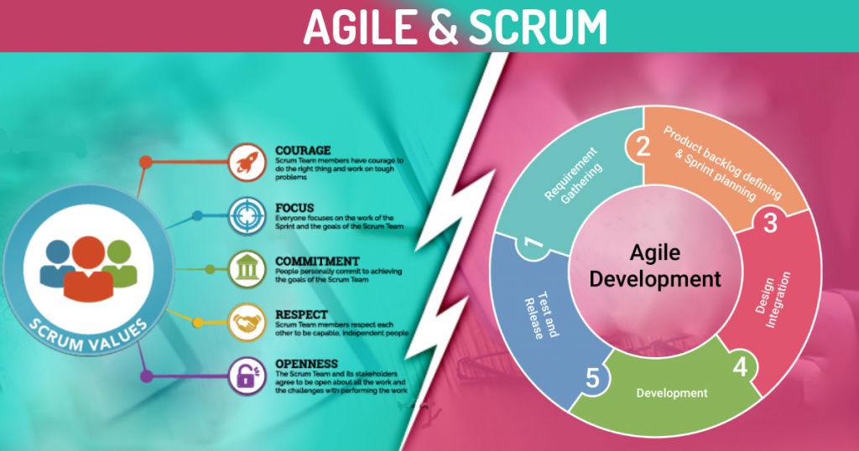

Planning is done before starting the project in the **Scrum Methodology**. All decided functionalities are divided into different sprints Each sprint is achieving one of the planned functionalities of the project. Each sprint is planned in a team meeting in the start of the sprint and a backlog is created on which all the members will follow.

1. In practice how effective did you find this methodology?

**Answer:**

All the methodologies have their own value depending on the requirement of the user if the user is uncertain about what he exactly needs then the agile methodology must be used but if all the criteria are crystal clear then scrum methodology would me a bonus.

1. What did you find was the strength of it?

**Answer:**

I find during this group project that the agile approach is more versatile, transparent, efficient and stakeholder satisfaction and responsiveness because everything is according to their understanding and needs and demands.

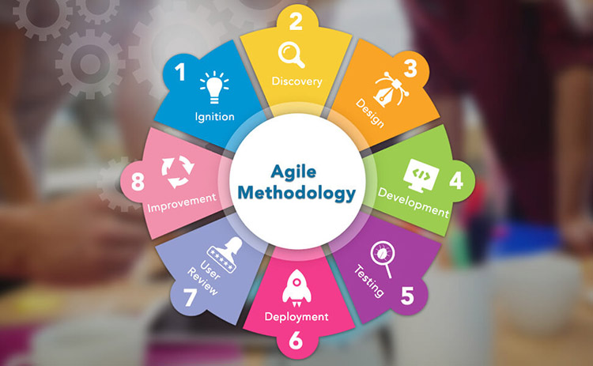

1. What were its weaknesses?

**Answer:**

The drawbacks I noticed during this group project are that the criteria of agile methodology do not always flow towards the developer finitely. Documentation is minimal because the planning is insufficient, and the findings are mostly fragmented in this approach.

1. What were the best features of the process?

**Answer:**

The features of agile methodology that are best according to me are stated as follows:

* Flexibility due to agility.
* Transparency of the project due to agility.
* Productivity of the agile methodology.

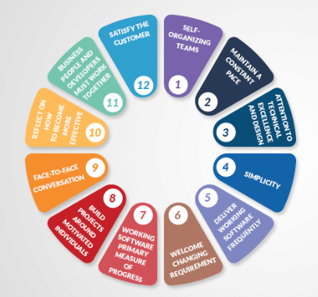

1. How did they appeal to you?

**Answer:**

These features make me more comfortable with my client as these features allow the clients to engage in all the app's growth process. Which adds to the satisfaction of the client.

1. What was the worst feature of the process?

**Answer:**

The worst feature I found in this process is the always creeping requirements from the client side. As new requirements and changes are always, there that makes the development time infinite.

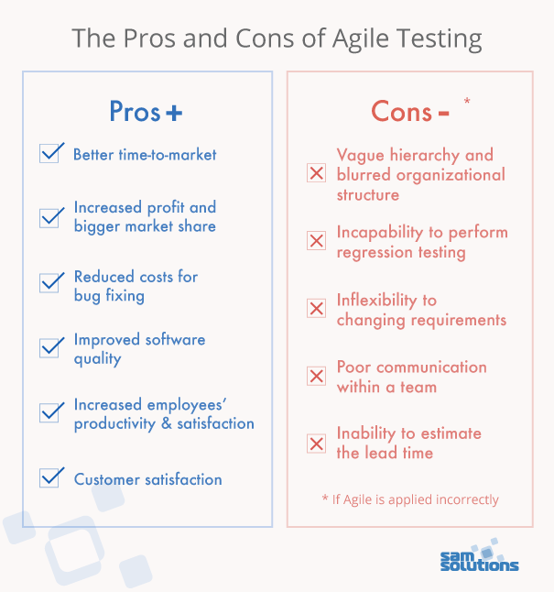

1. How would you change them?

**Answer:**

In my opinion thing must be sort out between the developer and the client reducing the creeping of the requirements.

### Group work

1. What did you enjoy about this style of programming?

**Answer:**

I enjoyed working with the project in this style because the client and the developer can see all the features and project progress that helps to increase understanding between the developer and the client.

1. What are the downsides for you of group work?

**Answer:**

I find that the group planning is disturbed as some requirement is creeped towards the developer.

1. How did this session change your opinion of working in industry?

**Answer:**

This session has changed my mind because I realize that working in a practical setting is not as easy as a college project, and certain technical and complex problems need to be handled properly, as the client is interested in the business.

### Source Control

1. What form of Source Control did you use?

**Answer:**

We used GitHub as source control of our application.



1. What were its strengths?

**Answer:**

The strengths for using GitHub are stated as follows:

* It makes it easy to contribute to the open-source project.
* Work can be show cased using GitHub.
* Changes can be easily tracked.
* We have integration options with other platforms on GitHub.

1. What were its weaknesses?

**Answer:**

The weaknesses for using GitHub are stated as follows:

* Security and pricing of the GitHub are the weaknesses of this source control platform.

1. How effective as a source control did you find it?

**Answer:**

This source control has proven extremely effective because it can be easily incorporated with any cloud and effectively managed app versions.

1. If you had to use it again what would you change?

**Answer:**

Security requirement will be improved.

### Other

1. Do you feel that this has been a worthwhile experiment?

**Answer:**

Yes.

1. Why? Why not?

**Answer:**

I found it a worthwhile experiment as it let is gain practical experience of the agile software development life cycle.

1. **If you had to give yourself a percent grade for your contribution to the project, and the process, what would it be?** Bearing in mind that you might have produced little, yet done the hard yards. Or you made heaps, but it was really easy.

**Answer:**

I would give me an **A** because I have done a lot of effort working in the group.